EVIDENCE-BASED PRACTICE

Table of Contents
Part One: Evidence-based Practice and its Approaches 3
Introduction 3
1.1 Evaluation of the Impact of evidence-based practices in decision-making 3
1.2 Assessment of tools and Methods in the Analysis process 4
1.3 Critical thinking related principles 5
1.4 Processes for decision making 7
1.5 Ethical perspectives can be utilized in decision-making 8
3.1 Measurement of financial and non-financial performance 9
3.2 Value-adding practices 9
Conclusion 10
Part Two: Quantitative and Qualitative Analysis Review 11
2.1Table 1 analysis 11
2.2 Table 2 Analysis 16
2.3 Recommendations 22
References 24

Part One: Evidence-based Practice and its Approaches

Introduction
Evidence-based practices (EBP) refer to the systematic approach often utilized for decision-making, followed by actions based on available evidence. The primary objective of EBP is to eliminate biases and subjective opinions to process actions grounded in real-world evidence with validation and reliability. The utilization of EBP offers revolutionary changes in several sectors, especially in healthcare settings as well as education and business management purposes. This report aims to demonstrate the significance of evidence-based practices and their application in navigating and solving organizations' issues according to the situation.

1.1 Evaluation of the Impact of evidence-based practices in decision-making
Evidence-based practices are essential to overcome unreliable decisions in the operational actions of business organizations. The perception of Eric Barends, Rob Briner, and Denise Rousseau outlines the problems of making effective management decisions based on information only (Cipd.org.com. 2024). Therefore, most organizations rely on evidence collected from multiple sources for the optimization of decisions as it offers proof of the results of previous actions. The basic principle of EBP involves the careful and deliberate application of current and relevant best evidence in making decisions. This guides to critically appraise the evidence to determine its validity, reliability, and applicability to the specific situation. Evidence can be obtained from various sources, including peer-reviewed research, work-based trial and error testing, practitioner experience and expertise, and feedback from stakeholders. The practice of evidence-driven strategies encourages comprehensive thinking and evaluation of the evidence for making informed decisions. According to Bell, (2022), the assessment of EBP includes assumptions, consideration of alternative perspectives, and identification of strengths and weaknesses of different evidence. The key impacts of EBP are as follows:
Improved decision quality: EBP ensures the reduction of errors emerging from biases through reliable and factual information on the latest trends. For instance, in the case of the hiring process of a company, evidence results in high-quality talent acquisition.
Reduction of cognitive bias: The world is overwhelmed with a lot of information and opinions of professionals and people that reflect contradiction in obtaining insights. This overload poses serious challenges leading to several biases regarding activities of authority, conformity, confirmation, and patternicity.
Enhanced professional credibility: The professionals using EBP provide more credible decisions with evidence that fosters trustworthiness among stakeholders, clients, and teammates. This strengthens the operations of a knowledge-based culture in business settings.
Effective organizational outcomes: The companies that integrate evidence-based actions benefit from effective strategies to improve efficiency even in evolving circumstances. The situation of the COVID-19 pandemic shows the most appropriate example of using EBP to navigate uncertainty with informed decisions in various industries (Lundgren et al., 2024).
Linking the research gaps: The practice of evidence-dependent outcomes integrates the practical applications of theoretical knowledge from different academic journals.
However, this practice includes a few challenges and considerations during the implementation, and those are the following:
Implementation Barriers: The over-dependency on EBP may cause challenges by resisting changes and lack of training. This requires potential leadership with the urge to continue development within the organizational culture.
Contextual Factors: The practice of evidence-based decision-making requires a strong foundation regarding organizational background, work policies, resources, and criteria of stakeholders.
Access to Quality Evidence: The EBP needs access to high-quality proofs from relevant areas through robust research infrastructure.
The avoidance of these challenges requires strategic planning and ethical practices to maximize the impact of evidence-based practices in developing decisions.
There are significant approaches in evidence-based practices such as critical thinking and rationale model.
Approach 1: Critical Thinking
Pros of critical thinking:
Enhanced Decision Making: Critical thinking provides the ability to the individuals to carefully analyse information which develops decisions that are more logical and informed depending more on evidence than assumptions.
Improves Problem Solving: critical thinking develops effective solutions for problems by considering different perspectives and breaking down complicated issues.
Open Mindedness: the concept of critical significantly provides consideration to different perspectives and acceptance of new information.
Adaptability: critical thinkers have the ability to adjust their process of thinking depending on changing situations and new evidence.
Cons of Critical Thinking: .
Analysis Dead-end: The instance of overthinking situations with providing consideration to every possible viewpoint has the potential to result in indecision and hesitations.
Potential of conflicts: Critical analysis can result in conflict or disagreement due to the aspect of challenging established viewpoints or beliefs.
Approach 2: Rationale Model
Pros of Rationale Model:
Comprehensive analysis: This provides importance to thorough analysis of all possible options and relevant data which results in well informed decisions.
Decreases Biasness: The model targets to reduce the effect of personal biases in decision making with systematic consideration of all aspects or factors and structured decision making.
Cons of Rationale Model:
Requirement of Time: The required time for collection and analysis of important data can be lengthy, particularly in situations where quick action is required.
Surplus of Information: The requirement of an extreme amount of data can result in an overload of information which will increase the difficulties to prioritize and process significant information.

1.2 Assessment of tools and Methods in the Analysis process
‘The Center for Evidence-Based Management (CEBMa)’ uses ‘Rapid Evidence Assessments (REAs)’ are a method to gather and critically evaluate the best available scientific evidence on a specific topic within a limited timeframe (Cebma.org.com. 2024). The organization provides information and support to managers, consultants, business personnel, teachers, academics, and others working with evidence-based decision-making and practices in the management and leadership field. Another standard method is randomized controlled trials (RCTs) to employ evidence-dependent research. It involves assigning participants to several groups randomly to compare the impact of interventions. This is accessed by students from several institutions and both profit and non-profit business organizations across the world. EBP can be practiced through qualitative research methods such as focus groups and interviews that offer in-depth insights into the perspectives of respondents. The outcomes of this assist in understanding complex social phenomena to generate hypotheses for future works. The selection of appropriate tools is based on quantitative and qualitative methods of the decision-making approaches. For quantitative study, the following tools and methods can be utilized,
Descriptive Statistics: The calculation of mean, mode, and standard deviation supports a wide range of statistical procedures. Another, software called SAS (Statistical Analysis System) offers advanced and predicted analytics, data management strategies, and business intelligence.
Inferential Statistics: The outputs of regression analysis, correlation, analysis of variance (ANOVA), and hypothesis testing through using SPSS make inferences regarding samples (Yaşar et al., 2020).
For the collection and analysis of qualitative data in evidence-based practices, the following tools and methods are applied,
Thematic Analysis: The evidence with recognition of patterns and themes from textual information offers deep insights about the concerned areas.
Case Studies: The affirmation of real-world case studies helps to initiate data collection and analysis for the processing the potential decision-making practices.
For mixed-methods software such as MAXQDA and NVivo can be used to integrate multiple data seamlessly. Decision-making for any sector can be supported by a SWOT analysis of the organization in a specific sector globally with an overview of strengths, weaknesses, opportunities, and threats globally. Based on the findings of EBP, cost-benefit analysis (CBA) and multi-criteria decision analysis (MCDA) helps to evaluate several factors. Moreover, the most important technique is to collect data from real-world scenarios that prioritize the experience of the practitioners to provide feedback and shape the decision-making. The ongoing process of EBP requires continuous development and training for the practitioners to stay updated about the newly emerging affirmations. The approaches of evidence-driven outputs involve a rigorous methodology with systematic reviews of multiple studies followed by meta-analysis. This ensures that the conclusion and recommendations for the task are originated based on high-quality evidence.
SWOT analysis tool and employee survey method can be eligible for evaluation.
Tool: SWOT Analysis
Pros of SWOT Analysis:
- This tool significantly contributes in the process of identifying opportunities and threats for the organization. It also favors assessing future potential requirements of the business.
- The tool has a simple framework which can be applicable for various different instances or situations.
Cons of SWOT Analysis:
- This tool has the potential to provide subjective or biased judgements.
- The results of this lack qualitative information or data and do not provide any particular plan for action.
Application:
SWOT analysis can be utilised in assessing significant issues in the organizational structure such as staff shortage and emerging challenges in the market such as new competitors.
Method: Employee Surveys
Pros of Employee Surveys:
- This method can provide direct insights of the organizational situation with collecting responses and personal experiences from the employees of different departments.
- Surveys have the potential to provide specific information about the areas that require improvement and changes in the organizational structure.
Cons of Employee Surveys
- Ineffective design or implementation of surveys can result in insufficient reception of participation which can affect the accuracy level of the results.
- The responses gathered from this method hold a significant amount of risk related to biases caused from feeling pressured to provide positive feedback.
Application:
The employee surveys are utilised in assessing the engagement levels of the employees and gain particular insights in the workforce. This is also used on identifying significant issues encountered by the employees and resolving them.

1.3 Critical thinking related principles
The concept of critical thinking plays a key role in academic research and significantly contributes to the process of analyzing information or results and decision-making. Essential thinking skills allow researchers, scholars, students, and teachers to understand complicated subjects, analyze data, and gather information from various sources while understanding significant concepts to develop innovative solutions (Barta et al. 2022). It is a disciplined process of visualization, analysis, application, evaluation, and collection of data actively and with skills. The core idea or concept of critical thinking is not only just a clear and rational process of thinking but also an independent, systematic, and reflective process. The core components of critical thinking are Evaluation, Inference, Explanation, and Self-regulation.
Principles of critical thinking
The concept of critical thinking has various principles provided by researchers and scholars in the world based on the practice nuances of it. Some of these principles are clarity, precision, logic, consistency, open-mindedness, doubtfulness, and neutrality (Peltonen, 2021).
Clarity: In any kind of research or study the information or arguments provided should be made in a comprehensible manner for the readers. The information provided in simple language should not open further question or make a concept look complicated (Liang, 2023).
Precision: Information or data used when conducting research or doing a study to give an understanding of the problem or argument, must be accurate according to the concept. This method of thinking guarantees that the data or information produced in any research or study is clear and accurate (Heard et al. 2020).This can be smoothed by data accumulating from various proven sources which are most current articles, journals and case studies which go through authors, researcher and scholars review scope for doubt or complexity (Liang, 2023). This fundamental principle ensures that the problem or argument in any research or study is well-defined and understandable.
Precision: Information or data provided in research or study to define the problem or argument clearly and make it understandable should be accurate and precise as per the concept. This principle of critical thinking ensures that the data or information provided in any research or study maintains precision and accuracy (Heard et al. 2020). It can be accomplished by collecting data from trusted and reliable sources, such as recent articles, journals, and case studies that are peer-reviewed by authors, researchers, and scholars. The students should apply principles to make them improve on their accuracy in the evaluating process.
Logic: Whenever arguments or problems presented and discussed in any research or study, they should be backed by reasons and real-life data. In fact, all the stages of the explanation should be justified by reasonable logics and the references to evidence (Haber, 2020). The decision made by the students should be able to be backed up by the course theory and concepts.
Consistency: The reasons for the issues or the arguments should correspond to the reasons that are understandable and are admissible according to the time. Students should also be logical in their thinking and define evidence based on such thinking (Parra et al. 2021). To those students I would recommend that they practice consistency in their ideas and concepts with evidence.
Open-mindedness: There is a significant requirement of open-mindedness in critical thinking for the acceptance of new evidence, alternative viewpoints, and counterarguments. This principle ensures that widely accepted beliefs are also being changed based on new evidence and logical reasoning (Hurajová and Hladíková, 2022).
Doubtfulness: Positive aspects of doubtfulness include questioning concepts and ideas of different subjects based on logic and evidence rather than believing them blindly. This ensures that all the explanations or opinions in a research or study are being questioned and demanded for evidence. It ensures the relevance of the unstated assumptions under the explained problems or arguments (Haber, 2020).
Neutrality: The concept of critical thinking suggests that students, researchers, and scholars be fair and unbiased. It ensures that all the relevant viewpoints are being considered and are free from conflict of interest and personal biases (Ho et al. 2023).
These principles also can be utilized in the process of individual or collective decision-making. In the decisions related to acquiring talent and the evaluation of diverse candidates, the principles of critical thinking will ensure a neutral and productive hiring process.
Application to Own Work: The principles of critical thinking can be applicable to review policy changes related to human resources with justifications driven by data.
Application to Other’s Work: These principals can be utilised in the evaluation of a consultant’s workforce analysis with verification of methodology and sources.

1.4 Processes for decision making
Rational decision-making: this is a structured process that utilizes objective knowledge and logic in the process of finding solutions for problems. The process involves various steps for decision-making. It first identifies the significant problems or arguments of the decision. Then it collects information or data about that specific argument or problem to analyse. Based on the analysis the process tries to find solutions for the arguments or problems (Bag et al. 2021). It also suggests examining or evaluating the other alternatives in the decision-making process. After the evaluation of the alternatives, the process suggests selecting the best possible option to make the decision. Based on the selection the process suggests taking applicable actions as per the solution. This process also suggests conducting a review of the provided decision and the impact of it on the solutions.
Participative decision-making: the process of participative decision-making is a collaborative way that includes multiple stakeholders in the process of decision-making. The process has a dynamic level of applicability to various decisions that involve operational, ethical, and strategic decisions. The dynamic range of PDM covers general or basic consultation to the decisions based on consensus (Carteni et al. 2022). Consultation is a decision process where employees provide inputs related to the problem or argument of decision but the leadership takes the last and final decision. On the other hand, a consensus-based decision-making process requires agreement of all the parties involved in the process on the final decision. The process significantly contributes to establishing a positive relationship between the leadership and the employees (Farzana and Charoensukmongkol, 2023). It replaces the autocracy process of decision-making in the organization with the effective process of group decision-making. It favors the organizations to have better results in the business operations. The positive practices that optimize the process of PDM involve various aspects. It ensures a safe and comfortable environment for the participation of the employees in the decision-making process (Coffeng et al. 2023). Inputs provided by the employees in the decision-making process should be taken seriously to accomplish the comfortability aspect. The objective or scope of the decisions should be outlined in the decision-making process. Transparency in the provided information is also a significant aspect of this process. Encouragement of the decisions and attentive listening practices in organizations can also optimize the process of PDM. This develops significant advantages in business organizations by implementing a strong company culture.

1.5 Ethical perspectives can be utilized in decision-making
Utilitarian Perspective: This is a moral philosophy that defines that the most effective actions are those that create the highest level of happiness for a huge number of people. The concept of this theory is based on consequences or outcomes. This means the results of any action decide its value. Dynamic features of this theory make it applicable to a wide range of concepts or subjects (Udoudom, 2021). The process has its applicability in laws and policies that favor identifying discardable laws and adoptable regulations based on their results or outcomes. The applicability of this theory is also visible in business organizations such as business management and product pricing-related decisions. This philosophy also has its applicability in human resource management such as decisions related to restructuring that provide importance to retain as many employees as possible.
Pros: This philosophy significantly focuses on promoting cost effective decisions for any organization.
Cons: It has the potential to neglect or overlook the rights of individual workers or employees in the organization.
Deontological Perspective: It is also a moral philosophy that provides its judgment on actions depending on the intentions behind them which are according to the rules. It does not consider the consequences of these actions in the judgment. "Deontological" word came from a Greek word known as 'Deon'. The meaning of this Greek word is duty which represents the whole concept of this philosophy. The concept of this theory provides importance to moral principles and duties (Sharif and Ghodoosi, 2022). In human resource management, maintaining and ensuring transparency and neutrality in the actions related to the disciplines of the work environment shows the applicability of this philosophy.
Pros: This moral philosophy ensures fairness in the individual rights and operations of the organization.
Cons: The philosophy can be difficult to implement in complex instances or scenarios of the organization.

3.1 Measurement of financial and non-financial performance
Financial Performance: Identification of the financial performance in human resource management is also a fundamental aspect to ensure the effectiveness of the evidence-based practices on the employees.
ROI (Return on Investment): Calculation of return on investment in the initiative related to evidence-based practices contributes to determining profitability (Tran et al. 2020). The calculation of return on investment in the training programs represents the financial impacts of these initiatives on the productivity of the employees. I suggest the students provide importance to the financial aspect of these initiatives to evaluate the perfect training programs for the employees.
Pros: The calculation of return on investment significantly contributes in measuring efficiency in generation of profit.
Cons: This process does not involve any qualitative information and benefits in its results.
Non-Financial performance: The nonfinancial aspects of these initiatives mostly involve the satisfaction level of the workforce and the morale aspect.
Employee Engagement Surveys: Surveys related to employee satisfaction determine the level of employer satisfaction and morale of the employees (Alsafadi and Altahat, 2021). The high-level score of engagement in these surveys represents the improvement of performance in the employees and the high retention level of talents. I suggest the students provide importance to the evaluation of nonfinancial performance also. It will favor them to analyze the engagement level of the employees with work-related operations and the moral encouragement level of the employees.
Pros: This significantly contributes in measuring workforce satisfaction in the organization.
Cons: The responses collected from this method have the potential to show biasness which can affect the outcomes of the survey.

3.2 Value-adding practices
The concept of People practices significantly contributes to the overall success of an organization and its business operations. The incorporation of evidence-based practices in people's practices significantly optimizes the success level of an organization. These practices favor the human resource management authority to improve the engagement level of the employees in the working operations (Dang et al. 2021). It also suggests supporting diversity in the workforce and initiatives related to inclusion which significantly contribute to the development of innovation in the organizations.
Measurement methods of these impacts
Employee turnover rates: The calculation of employee turnover provides significantly important insights into the workforce of an organization. The results of employee turnover define the stability of the workforce that ensures the future sustainability of the organization (Aburumman et al. 2020). In human resource management, the most important aspect is workforce stability. I will suggest the students provide significant importance to the identification of employee turnover rates. Calculation of the employee turnover rate will favor the students to assess the stability of the workforce in an organization.
The way employee turnover rates add value
- This favors to determine issues related to workforce stability and retention
- It provides insights related to employee engagement and satisfaction.
- The results significantly contribute to the process of rectifying strategies related to engagement and satisfaction of the employees.
Measurement of impact
- A high rate of turnover signifies that the HR have to assess competitiveness in salary, opportunities for career development and exit interviews.
- A significant decline in turnover rates after the above initiatives represents that the retention strategies are being effectives.

Performance Metrics: This process tracks and analyzes quantifiable data related to business activities, the behavior of the employees, and the overall productivity of the organization. Business organizations utilize this method to examine and evaluate the growth of the business compared to the expected results. It has a dynamic applicability that involves individual, group team, or organizational levels (Votto et al. 2021). The method is mostly utilized in the evaluation of an organization's financial performance, operational performance, and performance of the employees. In the evaluation process of evidence-based practices and their impact on the people practice-related initiatives of an organization, the method provides a significant level of contribution. It can evaluate the changes in productivity and project results to assess the impacts of the training initiatives.
The Way Performance Metrics Add Value
- This determines the requirements related to training and development.
- It assesses the effectiveness of the HR strategies and leadership.
- Significantly contributes in the process of incorporating compensation and promotion based on performance.
Common performance metrics and its impact on people practices
Productivity Rate: this significantly determines the skill gaps and requirement for training.
Performance Appraisal Scores: This significantly contributes in the process of talent development and promotions,
Employee Engagement Scores: This significantly contributes in assessing the HR strategies and workforce culture.
Measurement of Impact
- Decline in productivity signifies that the HR have to implement initiatives related to learning and development to upskill employees.
- The improvement in employee engagement scores after changes in HR policies develops a positive impact on morale.

Conclusion
After the above discussion, it can be said that the incorporation of evidence-based practices has a significant level of impact on the people practices of an organization. The initiatives based on the concept of evidence-based practice drastically improve the workforce performance of the organization and contribute to retaining talented individuals in the organization. The students should provide a significant level of importance to the concept of evidence-based practices and incorporate it in their future projects of human resource management.

Part Two: Quantitative and Qualitative Analysis Review

2.1Table 1 analysis
1. Administration Department

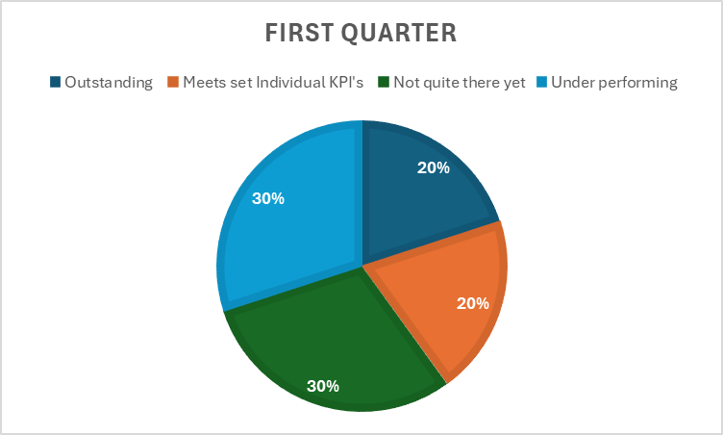
Figure 1.1: First quarter performance of the administration department
(Source: Excel)
Performance data for the first quarter of the administration department shows that two employees provided an outstanding level of performance that exceeded the provided target in the department which is 20% of the department. Also, two employees of the department fulfilled their targets of KPIs which is also 20% of the department. However, 3 employees could not fulfill their KPIs, and also 3 employees who are underperforming. According to the data, it is clear that the performance results of the department are more negative. It can be caused by insufficient training (Sawe et al. 2021).
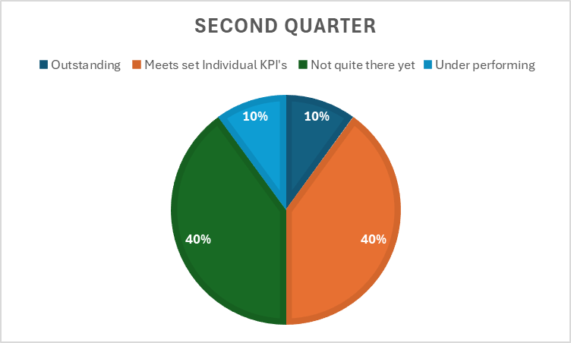
Figure 1.2: Second quarter performance of the administration department
(Source: Excel)
In the second quarter, the department's performance results showed balanced outcomes. Four of the employees, 20%, met their individual KPIs, and one of the employees, 10%, performed outstandingly in the quarter. On the other hand, four of the employees, 40%, could not fulfill their KPI targets, and one of the employees, 10%, underperformed in fulfilling their KPI targets.
One of the employees named Sally Sterling was absent in both quarters.
2. Sales Department

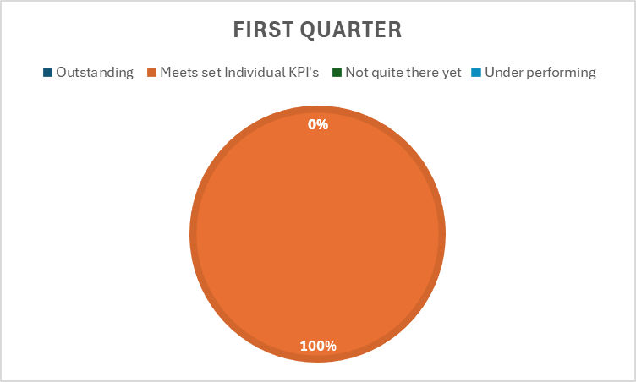
Figure 2.1: First quarter performance of the Sales Department
(Source: Excel)
The data for the first quarter in the sales department showed that 100% of the employees met their individual KPI targets. This represents that the department is performing well and the initiatives related to evidence-based practice in people practice had a positive impact on the department (Hume et al. 2021).
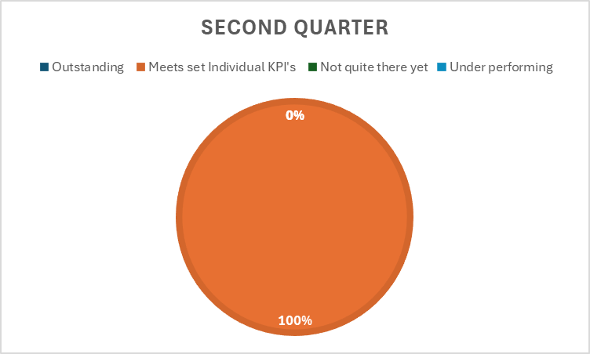

Figure 2.2: Second quarter performance of the Sales Department
(Source: Excel)
The second quarter data also showed 100% performance results of the employees in meeting their individual set KPIs.
3. Logistics department

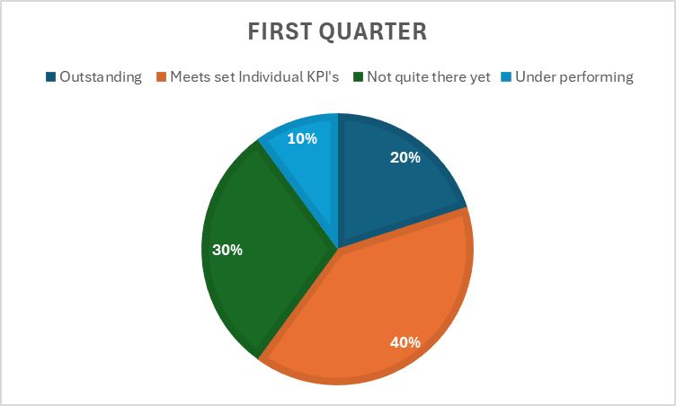
Figure 3.1: First quarter performance of the Logistics Department
(Source: Excel)
The performance data in the first quarter of the logistical department showed that 20% of the employees provided outstanding performance and 40% of the employees met their set individual KPIs. It also shows that 30% of the employees could not completely meet their targets and only 10% of the employees are underperforming. The aspect of increased employee engagement in the working operations is visible in the results (Byrne, 2022).
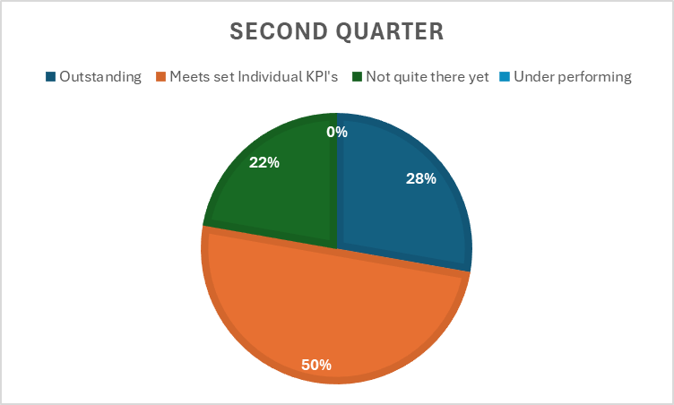
Figure 3.2: Second quarter performance of the Logistics Department
(Source: Excel)
In the second quarter, the data shows that 28% of the employees are providing outstanding performance, 50% met their set individual KPIs and 22% could not completely fulfill their individual set KPIs. The performance of this department is also on the positive side.
4. Research and Development

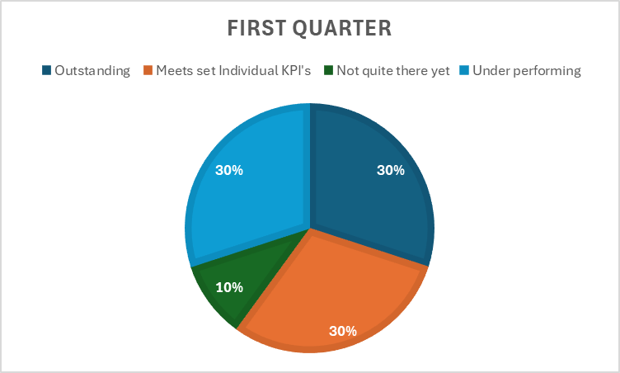
Figure 4.1: First quarter performance of Research and Development
(Source: Excel)
The performance data of this department in the first quarter shows that 30% of the employees are underperforming, which represents the adverse effects of the people practicing related initiatives. High and challenging targets decrease the morale of the employees (Latham, 2023).
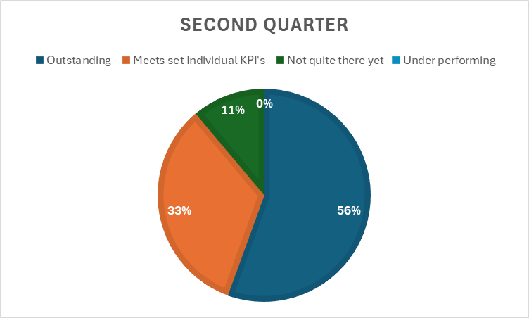
Figure 4.2: Second quarter performance of Research and Development
(Source: Excel)
In the second quarter, the performance data of the logistics department shows that 56% of the employees provided outstanding performance, 33% met their set individual KPIs and only 11% could not completely fulfill their KPI targets. It is a positive result for the logistics department that shows the increased employee engagement in the working operations caused by the people practices-related initiatives.

5. Bonus payment
Bonus payment for each employee
Administration department

Employee Name | Bonus payment for the first quarter | Bonus payment for the second quarter | Bonus payment
Robin Bird | £3,780.00 |  | £3,780.00
Saffron Finch | £2,880.00 | £2,880.00 | £5,760.00

Logistics department

Employee Name | Bonus payment for the first quarter | Bonus payment for the second quarter | Bonus payment
Ruth Sixsmith |  | £2,850.00 | £2,850.00
Wendy Boot |  | £2,850.00 | £2,850.00
Sally Rigbye | £2,850.00 |  | £2,850.00
Jean Livesey |  | £3,120.00 | £3,120.00
Julie Chisnall | £2,340.00 | £2,340.00 | £4,680.00
Rick Lovall | £2,340.00 |  | £2,340.00
Gill Jamieson | £2,340.00 | £2,340.00 | £4,680.00

Research and development

Employee Name | Bonus payment for the first quarter | Bonus payment for the second quarter | Bonus payment
Ethan Brar | £3,900.00 | £3,900.00 | £7,800.00
Harrison Briggs |  | £3,900.00 | £3,900.00
Steve Owens |  | £3,540.00 | £3,540.00
Tasha Graham | £3,540.00 | £3,540.00 | £7,080.00
Jennifer Frost | £3,540.00 | £3,540.00 | £7,080.00

The total overall cost of a bonus payment of the organization = £62,310.00

2.2 Table 2 Analysis
1. Feedback responses from line managers (50 responses)

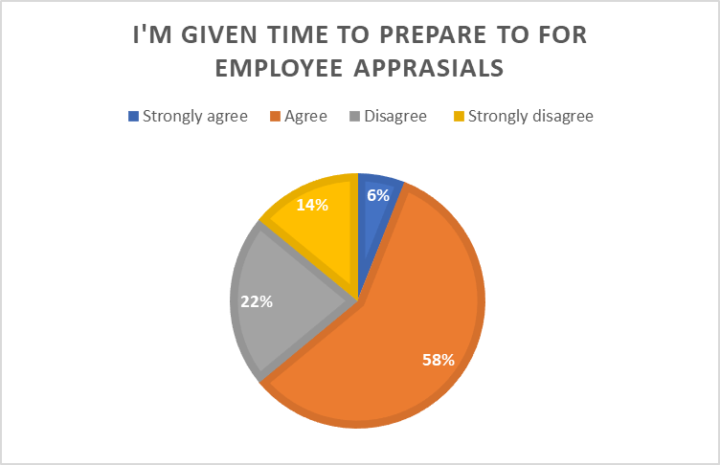
Figure 1.1: Provided Preparation Time for Employee Appraisals
(Source: Excel)
In the response data to the first question, it is clear that 58% of the participants agree that they are provided with enough time for their preparation.
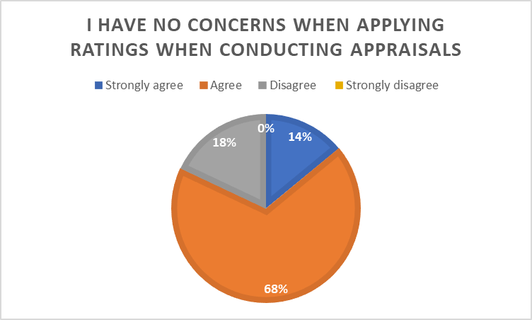
Figure 1.2: Concerns about providing rating during the conduction of appraisals
(Source: Excel)
The response data shows that 68% of the participants agree and 14% of the participants strongly agree that they have no concerns related to the application of ratings during the conduction of appraisals.

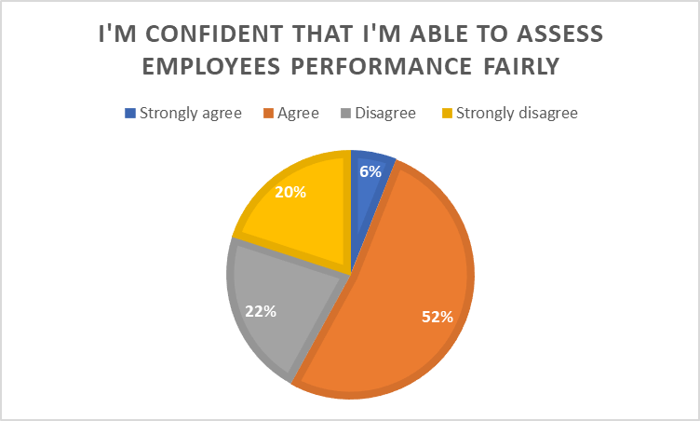
Figure 1.3: Confidence in assessing employee performance
(Source: Excel)
In the response data, it is clear that 52% of the participants agreed and 6% strongly agreed that they are confident in their ability to assess the performance of the employees fairly.

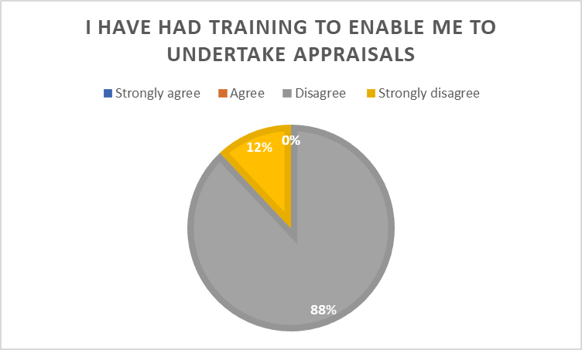
Figure 1.4: Appraisal undertaking related training
(Source: Excel)
The responses show that 88% of the participants disagreed that they had specific training for undertaking appraisals.
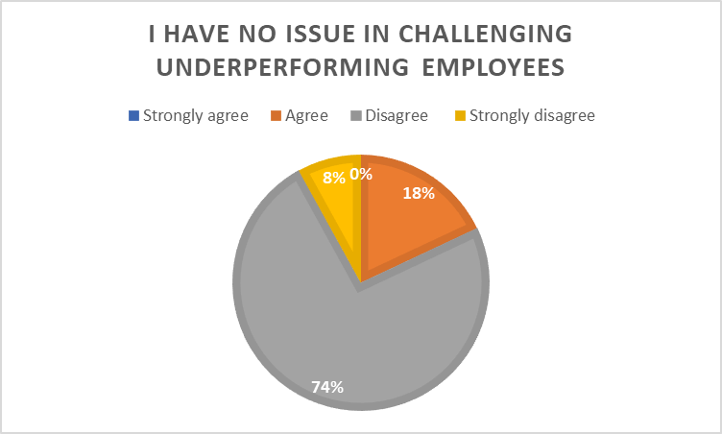
Figure 1.5: Issues related to challenging underperforming employees
(Source: Excel)
In the response data, it is clear that 74% of the respondents disagree and 8% strongly disagree that they have no issues in challenging underperforming employees.
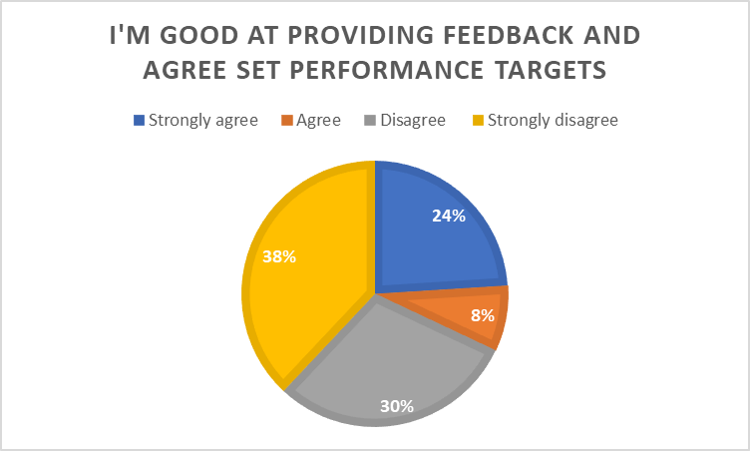
Figure 1.6: Providing feedback and setting performance targets
(Source: Excel)
In the data, 38% of the participants strongly disagreed and 30% disagreed that they are good at providing feedback and agreed to set performance targets.

2. Feedback responses from employees (235 responses)
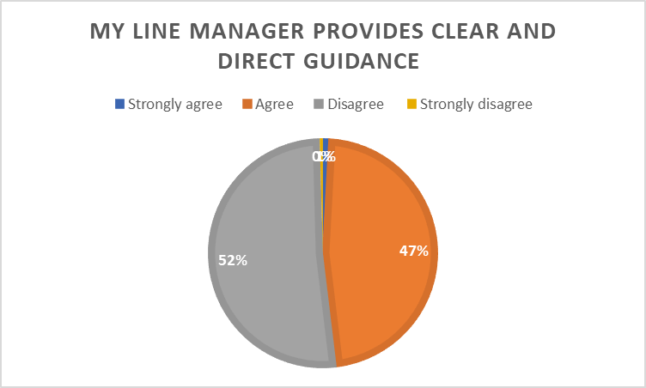
Figure 2.1: Guidance provided by line manager
(Source: Excel)
The data shows that 52% of the participants disagree and 47% of the participants agree that their line manager provides clear and direct guidance. It showed balanced results which will not provide any conclusions.
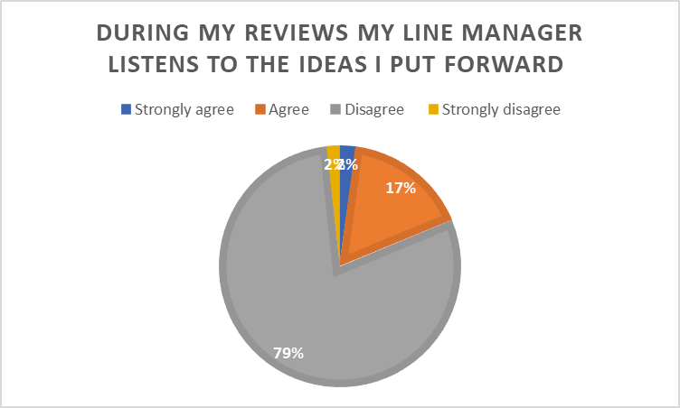
Figure 2.2: Reception of line manager to provide reviews
(Source: Excel)
In the data, 79% of the respondents disagree that their line managers listen to their ideas.

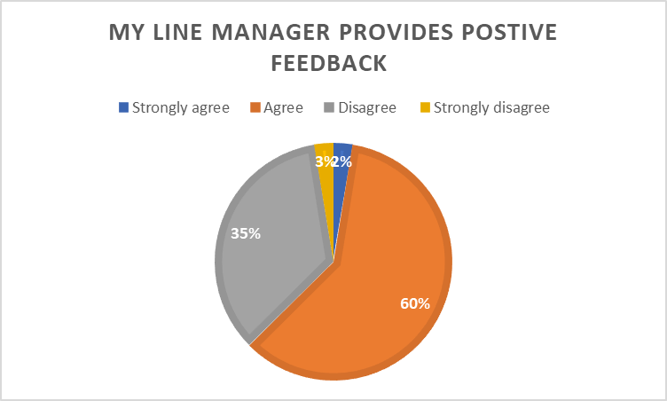
Figure 2.3: Positive feedback provided by line manager
(Source: Excel)
The data shows that 60% of the participants agree that their line managers provide positive feedback.
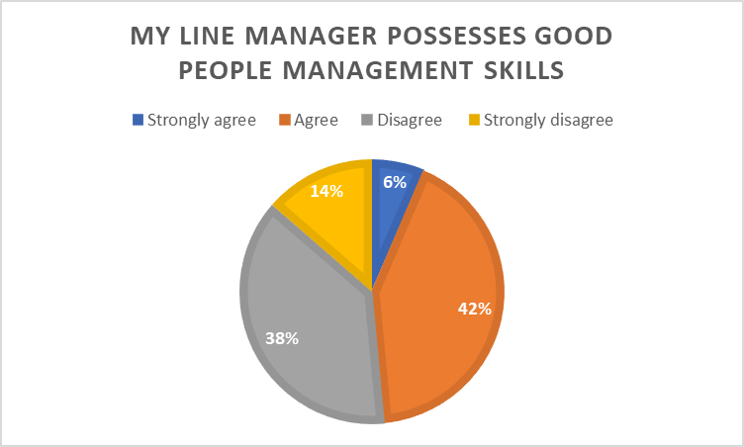
Figure 2.4: Good people management skills possessed by line manager
(Source: Excel)
In the data 42% of the participants agreed and 38% of the participants disagreed that their line manager possesses good people management skills.
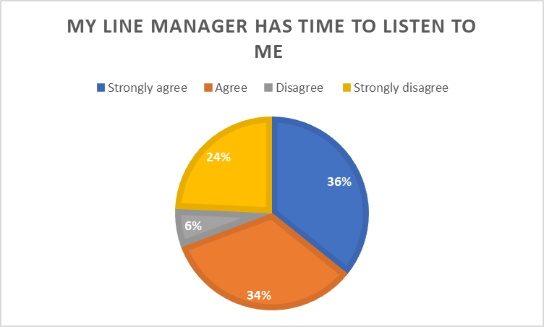
Figure 2.5: Listening capability of line manager
(Source: Excel)
In the data, 36% of the participants strongly agreed and 34% of the participants agreed that their line manager has time to listen to them.
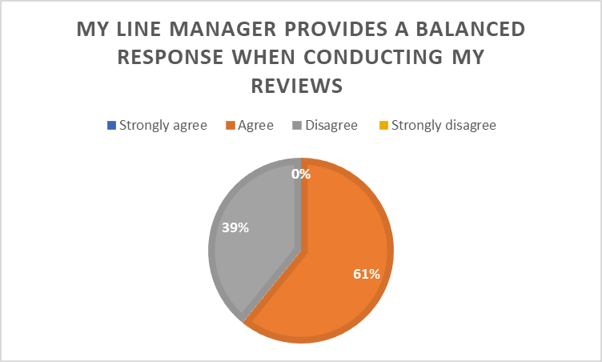
Figure 2.6: Provided balanced response by the line manager
(Source: Excel)
The response data shows that 61% of the participants agreed that their line manager provides a balanced response during reviews.

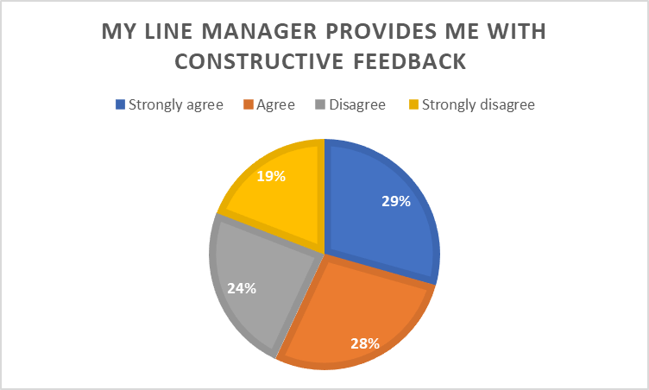
Figure 2.7: Constructive feedback provided by line manager
(Source: Excel)
In the data, 29% of the participants strongly agreed and 28% agreed that their line manager provides constructive feedback.
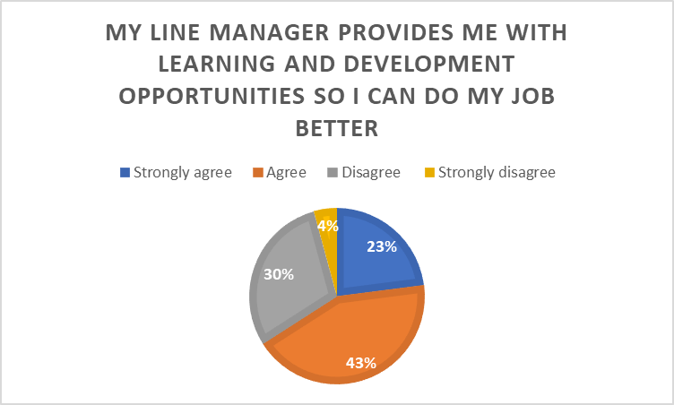
Figure 2.8: Provided learning and development opportunities by the line manager
(Source: Excel)
The data shows that 43% of the respondents agreed and 23% strongly agreed that their line manager provides learning and development opportunities to them.

2.3 Recommendations
Table 1 shows that the administration department was quite negatively performing in the first quarter but showed some positive improvements in the second quarter. The sales department was performing outstandingly in both of the quarters. The logistical department consistently showed positive results in both the quarters. Although, the research and development department were quite underperforming in the first quarter but showed drastic improvements in the second quarter.
In Table 2 it is clear that the line managers provide preparation time and rating for employee appraisals. They are also confident in their ability to fairly assess the performance of the employees. However, the responses shows that the majority of the line managers disagrees that they had any specific training related to undertaking appraisals. These responses also indicate that most of the line managers disagree that they have no issues with challenging underperforming employees. They are also not confident in their feedback providing capability and setting targets related to performance.
On the other hand, the responses from the employees are naturally divided in terms of receiving clear and direct guidance, constructive feedback and people management skills from the line managers. However, most of the employees disagree that the line managers listen to their ideas. Most of the employees agree that their line manager provides positive feedback, balanced response, learning opportunities and has time to listen to them.
- The organization has to provide significant importance to its administration department, especially on the first quarter results in the table one.
The organization has to provide training to the line managers based on evidence based practices to the line managers for undertaking appraisals. Initiatives related to people practices can also develop confidence in the line managers to provide feedback and setting performance related targets. The principles of evidence-based practices will also make them able to listen to the ideas of the employees.

References
Aburumman, O., Salleh, A., Omar, K. and Abadi, M., 2020. The impact of human resource management practices and career satisfaction on employee’s turnover intention. Management Science Letters, 10(3), pp.641-652. http://m.growingscience.com/beta/msl/3476-the-impact-of-human-resource-management-practices-and-career-satisfaction-on-employees-turnover-intention.html
Alsafadi, Y. and Altahat, S., 2021. Human resource management practices and employee performance: the role of job satisfaction. The Journal of Asian Finance, Economics and Business, 8(1), pp.519-529. https://koreascience.kr/article/JAKO202100569425324.page
Bag, S., Gupta, S., Kumar, A. and Sivarajah, U., 2021. An integrated artificial intelligence framework for knowledge creation and B2B marketing rational decision making for improving firm performance. Industrial marketing management, 92, pp.178-189. https://www.sciencedirect.com/science/article/pii/S0019850120309044
Barta, A., Fodor, L.A., Tamas, B. and Szamoskozi, I., 2022. The development of students critical thinking abilities and dispositions through the concept mapping learning method–A meta-analysis. Educational Research Review, 37, p.100481. https://www.sciencedirect.com/science/article/pii/S1747938X22000501
Bell, E.C., 2022. Values-Based practice in EBLIP: A review. Evidence Based Library and Information Practice, 17(3), pp.119-134. https://www.erudit.org/en/journals/eblip/2022-v17-n3-eblip07316/1092536ar.pdf
Byrne, Z.S., 2022. Understanding employee engagement: Theory, research, and practice. Routledge. https://www.taylorfrancis.com/books/mono/10.4324/9781003171133/understanding-employee-engagement-zinta-byrne
Carteni, A., Marzano, V., Henke, I. and Cascetta, E., 2022. A cognitive and participative decision-making model for transportation planning under different uncertainty levels. Transport Policy, 116, pp.386-398. https://www.sciencedirect.com/science/article/pii/S0967070X21003668
Cebma.org.com. 2024. Our Clients & Strategic Partners. Available at: https://cebma.org/about-us/our-clients-and-strategic-partners/ [Accessed on: 26.12.24]
Cipd.org.com. 2024. Evidence-based practice for effective decision-making. Available at:. https://www.cipd.org/uk/knowledge/factsheets/evidence-based-practice-factsheet/#why-is-evidence-based-practice-important [Accessed on: 26.12.24]
Coffeng, T., van Steenbergen, E.F., de Vries, F., Steffens, N.K. and Ellemers, N., 2023. Reflective and decisive supervision: The role of participative leadership and team climate in joint decision‐making. Regulation & Governance, 17(1), pp.290-309. https://onlinelibrary.wiley.com/doi/abs/10.1111/rego.12449
Dang, D., Dearholt, S.L., Bissett, K., Ascenzi, J. and Whalen, M., 2021. Johns Hopkins evidence-based practice for nurses and healthcare professionals: Model and guidelines. Sigma Theta Tau. https://books.google.com/books?hl=en&lr=&id=m4k4EAAAQBAJ&oi=fnd&pg=PP1&dq=valu+adding+practices+in+evidence+based+practices&ots=pVLvzCBewb&sig=D8jNdShLTLzbNxJkO-5fu_GFXhs
Farzana, S. and Charoensukmongkol, P., 2023. Using approach-inhibition theory of power to explain how participative decision-making enhances innovative work behavior of high power distance-oriented employees. Journal of Organizational Effectiveness: People and Performance, 10(4), pp.565-581. https://www.emerald.com/insight/content/doi/10.1108/JOEPP-10-2022-0304/full/html
Haber, J., 2020. Critical thinking. MIT Press. https://books.google.com/books?hl=en&lr=&id=Es_XDwAAQBAJ&oi=fnd&pg=PR7&dq=critical+thinking+principles+logic&ots=SnlCxjqymI&sig=ryp_ewC6O2hgKc1pIqRtQ_2AqSA
Heard, J., Scoular, C., Duckworth, D., Ramalingam, D. and Teo, I., 2020. Critical thinking: Skill development framework. https://research.acer.edu.au/ar_misc/41/
Ho, Y.R., Chen, B.Y. and Li, C.M., 2023. Thinking more wisely: using the Socratic method to develop critical thinking skills amongst healthcare students. BMC medical education, 23(1), p.173. https://link.springer.com/article/10.1186/s12909-023-04134-2
Hume, K., Steinbrenner, J.R., Odom, S.L., Morin, K.L., Nowell, S.W., Tomaszewski, B., Szendrey, S., McIntyre, N.S., Yücesoy-Özkan, S. and Savage, M.N., 2021. Evidence-based practices for children, youth, and young adults with autism: Third generation review. Journal of autism and developmental disorders, pp.1-20. https://link.springer.com/article/10.1007/s10803-020-04844-2
Hurajová, A. and Hladíková, V., 2022. Educating for good character: from critical thinking to intellectual character virtues. Media Literacy and Academic Research, 5(1), pp.178-191. https://www.ceeol.com/search/article-detail?id=1037694
Latham, G.P., 2023. Motivate employee performance through goal setting. Principles of Organizational Behavior: The Handbook of Evidence‐Based Management 3rd Edition, pp.83-111. https://onlinelibrary.wiley.com/doi/abs/10.1002/9781394320769.ch5
Liang, W., 2023. Towards a set of design principles for technology-assisted critical-thinking cultivation: A synthesis of research in English language education. Thinking Skills and Creativity, 47, p.101203. https://www.sciencedirect.com/science/article/pii/S1871187122002048
Lundgren, H., Papanagnou, D., Morrone, C., Vaid, U., Ghei, R., Bierowski, A., Watkins, K.E. and Marsick, V.J., 2024. From research to resources: developing a case-based learning curriculum for navigating clinical uncertainty. European Journal of Training and Development. https://www.emerald.com/insight/content/doi/10.1108/EJTD-03-2024-0044/full/html
Parra, Y.J.F., Barriga, A.M., Díaz, R.A.L. and Cuesta, J.A.G., 2021. Teacher education and critical thinking: Systematizing theoretical perspectives and formative experiences in Latin America. Revista de Investigación Educativa, 39(1), pp.149-167. https://revistas.um.es/rie/article/view/416271
Peltonen, L.M., 2021. Principles of Assessment Designing & Evaluating Critical Thinking Skills. https://researchportal.helsinki.fi/en/publications/principles-of-assessment-designing-amp-evaluating-critical-thinki
Sawe, F.B., Kumar, A., Garza‐Reyes, J.A. and Agrawal, R., 2021. Assessing people‐driven factors for circular economy practices in small and medium‐sized enterprise supply chains: Business strategies and environmental perspectives. Business Strategy and the Environment, 30(7), pp.2951-2965. https://onlinelibrary.wiley.com/doi/abs/10.1002/bse.2781
Sharif, M.M. and Ghodoosi, F., 2022. The ethics of blockchain in organizations. Journal of Business Ethics, 178(4), pp.1009-1025. https://link.springer.com/article/10.1007/s10551-022-05058-5
Tran, L.T., Rahimi, M., Tan, G., Dang, X.T. and Le, N., 2020. Post-study work for international graduates in Australia: Opportunity to enhance employability, get a return on investment or secure migration?. Globalisation, Societies and Education, 18(5), pp.495-510. https://www.tandfonline.com/doi/abs/10.1080/14767724.2020.1789449
Udoudom, M., 2021. The value of nature: Utilitarian perspective. GNOSI: An Interdisciplinary Journal of Human Theory and Praxis, 4(1 (May)), pp.31-46. http://gnosijournal.com/index.php/gnosi/article/view/100
Votto, A.M., Valecha, R., Najafirad, P. and Rao, H.R., 2021. Artificial intelligence in tactical human resource management: A systematic literature review. International Journal of Information Management Data Insights, 1(2), p.100047. https://www.sciencedirect.com/science/article/pii/S2667096821000409
Yaşar, Ş., Arslan, A., Çolak, C. and Yoloğlu, S., 2020. A developed interactive web application for statistical analysis: statistical analysis software. Middle Black Sea Journal of Health Science, 6(2), pp.227-239. https://dergipark.org.tr/en/download/article-file/1267088

